Architectural Document
Project: ARTNEST – Personal Museum Memory & Wishlist
Course: IN-SDE-EN-CMK

Table of Contents
Architectural Document 1
1. Introduction 1
2. C4 Model 1
3. Conceptual Model (EER) 3
4. Class Diagram 4
5. Database Diagram (ERD) 4
6. Conclusion 5

Introduction
This document describes the architecture and system design of ARTNEST. The purpose of this document is to show how the system is structured and how its main parts connect to each other. The design is based on the analysis phase, especially the use cases and requirements defined in the URS.
ARTNEST is designed as a web application that helps museum visitors discover artworks, save them to a wishlist, mark them as visited, and write personal reflections. To support these features, the system needs a clear structure that separates the user interface, the logic of the application, and the storage of data.

C4 Model
To explain the structure of ARTNEST, I used the C4 model and focused on the first two levels: the System Context Diagram (Level 1) and the Container Diagram (Level 2).

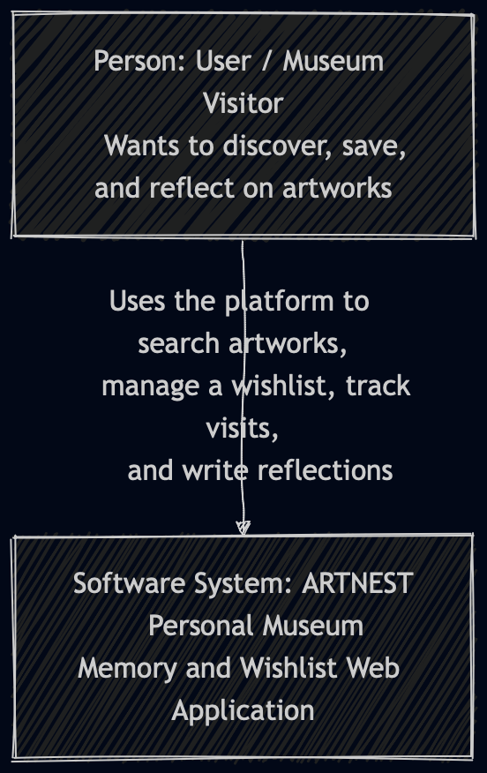

The System Context Diagram shows ARTNEST as a whole system and how the user interacts with it. The user is a museum visitor or art lover who uses the platform to search for artworks, view details, save them to a wishlist, mark them as visited, and write reflections. In this diagram, the focus is on what the system does and who uses it, without going into technical details.
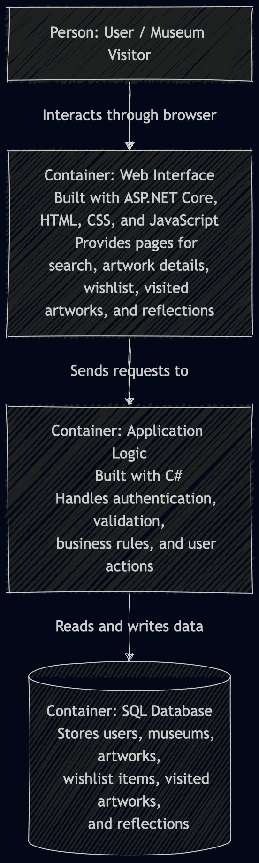
The Container Diagram goes one step further and shows how the system is structured internally. ARTNEST is divided into three main parts: the frontend, the backend, and the database. The frontend is the part the user interacts with, the backend handles the logic and processes requests, and the database stores all system data such as users, artworks, museums, wishlist entries, visited artworks, and reflections.
These two diagrams help show both the general purpose of the system and its internal structure. They also connect directly to the use cases from the URS, since each user action passes through these parts of the system.

Conceptual Model (EER)
The EER diagram shows the main entities in ARTNEST and the relationships between them. I used this model to create a clear overview of the system before moving into more technical design.
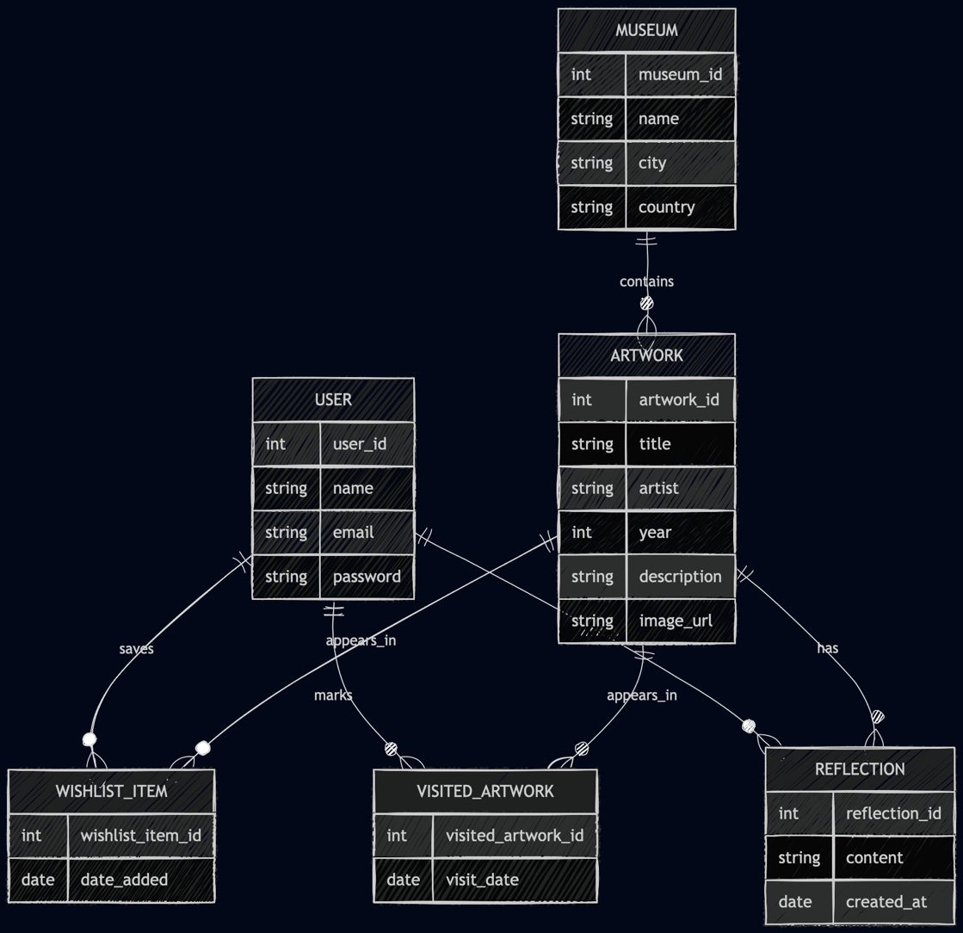
The main entities in the system are User, Museum, Artwork, Wishlist Item, Visited Artwork, and Reflection.
A User can save artworks to a wishlist, mark artworks as visited, and write reflections about artworks. An Artworkbelongs to a Museum, which connects the artwork to a physical location. The entities Wishlist Item, Visited Artwork, and Reflection represent actions or interactions between the user and the artwork. These entities are important because they make ARTNEST more personal and support the idea of tracking museum experiences over time.
This model helped me understand what kind of data the system needs and how the most important parts of ARTNEST are connected.

Class Diagram
The class diagram shows the same system from a software point of view. It is based on the conceptual model, but here the focus is on the classes and their attributes.
The main classes are User, Museum, Artwork, WishlistItem, VisitedArtwork, and Reflection.
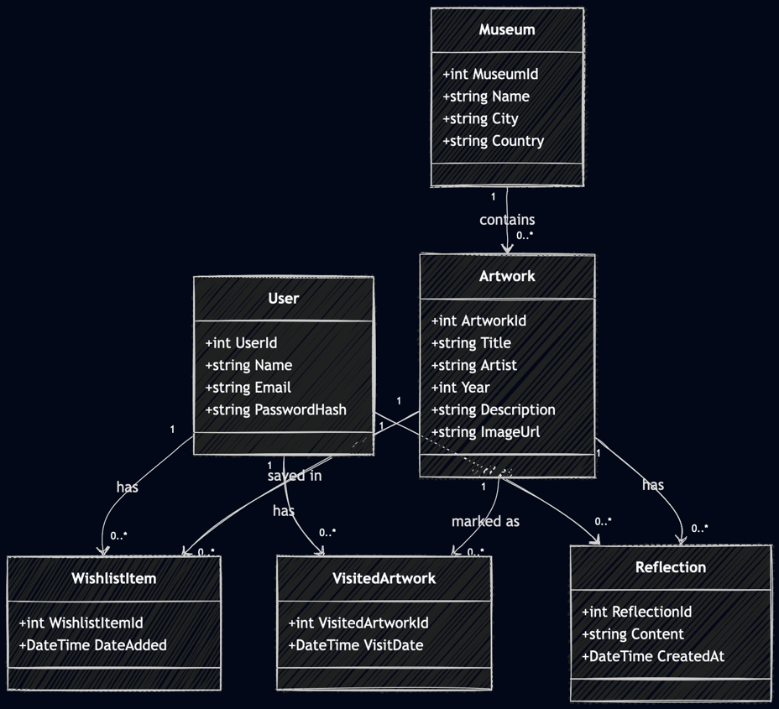
The User class stores basic user information such as name, email, and password hash. The Museum class stores data about museums, such as name, city, and country. The Artwork class contains information such as title, artist, year, description, and image.
The classes WishlistItem, VisitedArtwork, and Reflection are used to connect users with artworks through different actions. A user can have many wishlist items, many visited artworks, and many reflections. In the same way, one artwork can appear in many wishlist items, visited entries, and reflections.
This diagram helped me move from a general system structure to a design that is closer to implementation.

Database Diagram (ERD)
The ERD shows how the system is represented in the database. It translates the conceptual model into tables with primary keys and foreign keys.
The main tables are Users, Museums, Artworks, Wishlist_Items, Visited_Artworks, and Reflections.
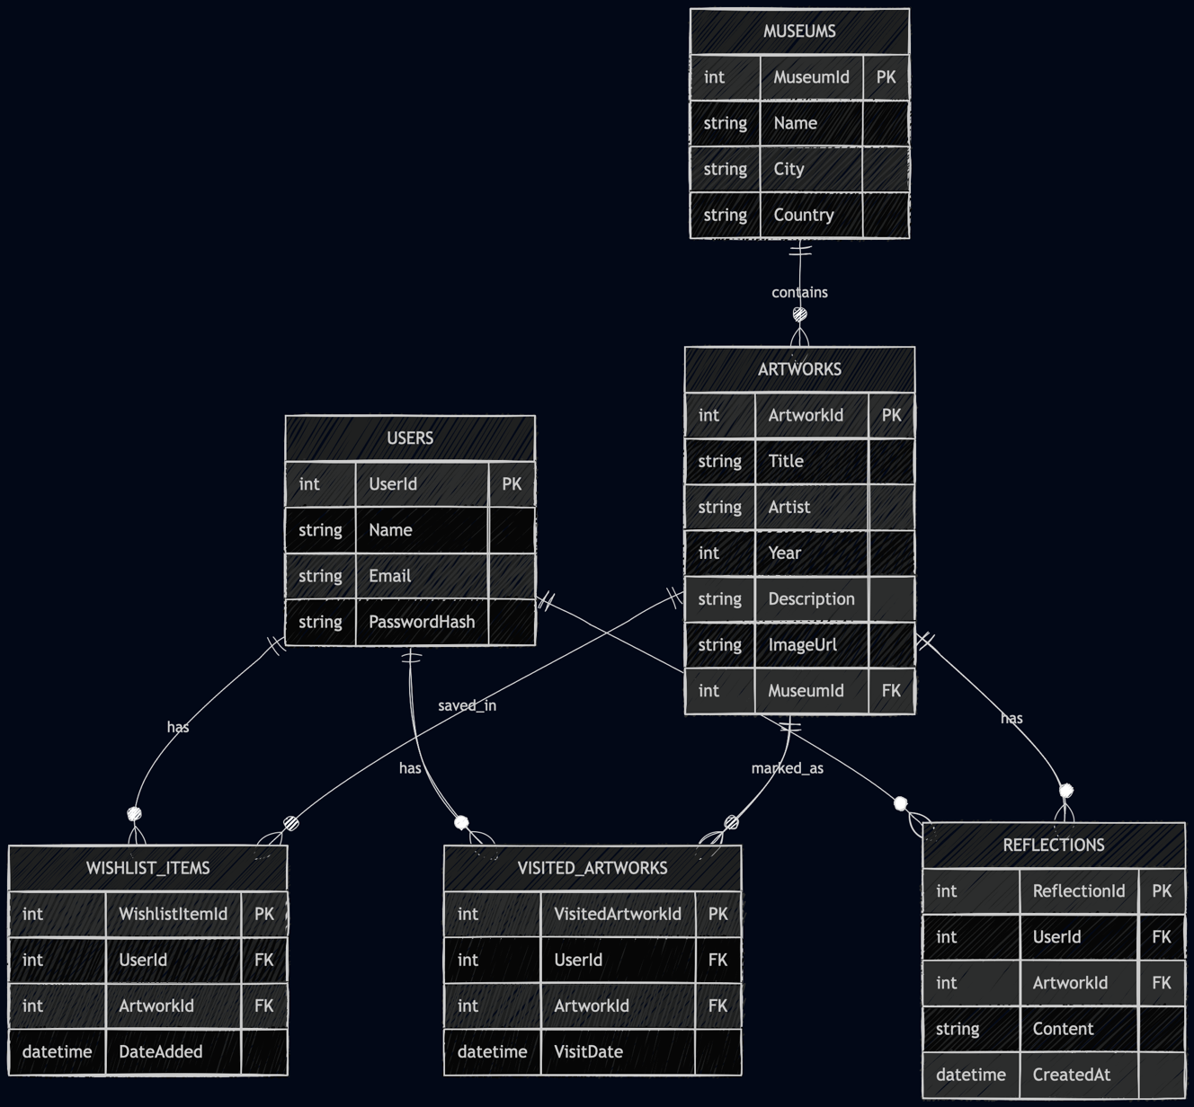
The Users table stores account information. The Museums table stores information about museums. The Artworks table stores artwork details and includes a foreign key to the museum it belongs to. The other three tables store user interactions with artworks. Wishlist_Items stores artworks saved by users, Visited_Artworks stores which artworks a user has seen, and Reflections stores personal notes written by users.
This database structure supports the main functionality of ARTNEST and makes it possible to store personal museum journeys in a structured way.

Conclusion
The architecture of ARTNEST is based on the analysis phase and supports the main use cases of the system. By using the C4 model, conceptual model, class diagram, and ERD, I was able to move step by step from a general idea to a more technical design.
These models helped me understand both the functional side of the project and the technical structure needed to build it. Together, they form a strong foundation for the implementation phase of ARTNEST.

